
DEPARTMENT OF

COMPUTER SCIENCE & ENGINEERING

Experiment: 2
Student Name: Ashmit Agrawal UID: 23BCS11854
Branch: B.E.- C.S.E. Section/Group: 23BCS_KRG-1A
Semester: 6 Date of Performance: 12-01-26
Subject Name: System Design Subject Code: 23CSH-314

- Aim: To design and analyze the system architecture of an E-Commerce platform covering product listing, user and product storage, cart functionality, and payment processing using an event-driven Kafka mechanism.

Objective:
- To understand the architecture of an E-Commerce platform
- To design High Level Design (HLD) and Low Level Design (LLD)
- To study user, product, and cart management workflows
- To understand asynchronous payment processing using Kafka
- To analyze scalability, reliability, and performance of the system

Requirements (Tools):
- Draw.io for system design diagrams
- Backend services (conceptual – microservices based)
- Apache Kafka (for payment event handling)
- Database (SQL / NoSQL – conceptual)
- API testing tool (Postman)
- Procedure and Output:

Functional Requirements:

- User should be able to register and log in
- User should be able to view product listings
- User should be able to add or remove products from cart
- System should store user, product, and cart data
- Order confirmation should be generated after successful payment

Non-functional requirements:

- Latency: Low response time for product listing and cart operations
- Availability: 24 × 7 system availability
- Scalability: Horizontal scaling of services
- Reliability: Payment processing should be fault-tolerant
- Consistency: Accurate order and payment data
- Security: Secure payment and user authentication

High Level Design (HLD)
The High Level Design of the E-Commerce platform consists of the following components:
- Client (Web / Mobile): Interacts with the platform
- API Gateway: Routes requests to appropriate services
- User Service: Manages user data and authentication
- Product Service: Handles product listing and inventory
- Cart Service: Manages cart operations
- Payment Service: Initiates payment processing
- Kafka Broker: Handles asynchronous payment events
- Database: Stores user, product, cart, and order data
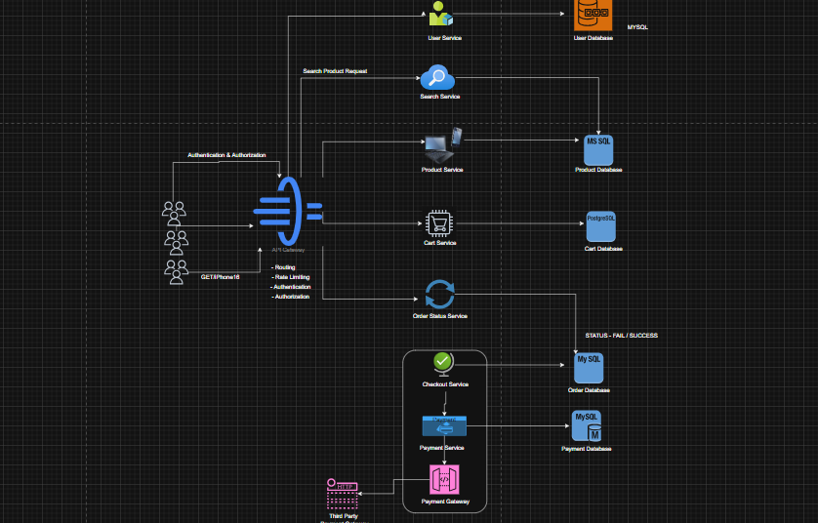

Low Level Design(LLD)

User Service
- Handles user registration and login
- Stores user details in the User Database

Product Service
- Fetches product listings
- Stores product details and inventory

Cart Service
- Adds and removes products from cart
- Calculates total price

Payment Service (Kafka-based)
- Produces payment request events to Kafka
- Listens for payment status events
- Updates order status after successful payment
Kafka decouples the payment service from other services, improving system reliability and scalability.

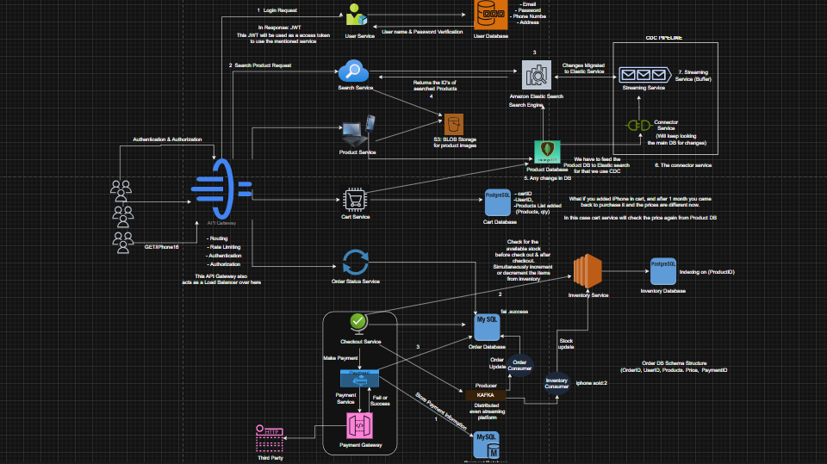

Learning Outcomes:
Understood E-Commerce system architecture
Learned microservices-based design approach
Gained knowledge of Kafka and event-driven systems
Designed scalable and reliable payment workflows

